caAERS Release 2

Use Case Document
Version 2.7

DOCUMENT REVISION HISTORY
Version Number | Date | Description
1.0 | April 2004 | COH completed Release 1 of caAERS
2.0 | January 19, 2007 | First iteration of Release 2 completed by Semantic Bits, et al
2.1 | January 23, 2007 | Sean Whitaker, Update template and revise use cases
2.2 | February 28, 2007 | SW, incorporate Niket’s feedback and changes from It 2
2.3 | April 9, 2007 | Changes from Iteration 2 of Construction Phase
2.4 | May 8, 2007 | Changes from F2F and Adopter feedback
2.5 | June 11, 2007 | Additional Use Cases and Changes as per Lisa’s feedback
2.6 | June 25, 2007 | CTMSi Use Cases and changes as per adopter feedback
2.6.1 | July 2, 2007 | Modifications to import use cases
2.6.2 | August 21, 2007 | Address feedback from BAH
2.6.3 | August 27, 2007 | Fillout use cases in mods 3 and 4
2.6.4 | October 4, 2007 | Address comments, add Ruleset diagram
2.6.5 | October 8, 2007 | Reorder Use Cases, remove deprecated parts
2.7 | October 16, 2007 | Add Use Cases for Import and Export Rulesets, Registration info from C3PR

Table of Content
1 Introduction 4
1.1 Project Overview 4
1.2 Document Overview 5
1.3 Related Documents 5
2 Actors and Goals 6
3 Use Cases 7
1 Module 1: AE Data Capture 7
1.1 Create Study for AE Data Entry 7
1.2 Create Subject 9
1.3 Assign Subject to a Study 10
1.4 Study Abstraction – Sponsors, Committees and Organizations 11
1.5 Create Expedited AE Report 13
1.6 Enter Routine AEs 15
1.7 AE Data Collection 16
1.8 Search AE Entry 17
2 Module 2: Interface to Local Clinical Trial Databases 19
2.1 Import Study Data 19
2.2 Import Patient Data 20
3 Module 3: Mapping to Vocabularies and Coding Systems 21
3.1 Select Appropriate Vocabulary for Study 21
4 Module 4: Report Generation and Submission to External Agencies 22
4.1 Create Report Definition 24
4.2 Create AE Ruleset 24
4.3 Configure Messages, Timing and Escalation Rules for Notifications 26
4.4 Import Rulesets 27
4.5 Export Rulesets 28
5. CTMSi Use Cases 28
5.1 Push AE Notifications to Patient Study Calendar 29
5.2 Create Expedited Report with Data from CTOM Lab Viewer 29
5.3 Receive Patient Registration from C3PR 30
4 Sign Off 32
4.1 Approval 32

Introduction

Project Overview
The purpose of this project is to develop and deploy an adverse event reporting system that is nationally scalable with a robust architecture to meet the needs of the caBIG™ Community. The caAERS requirements, data model, and use cases developed during Release 1 will be the foundation for this effort. The Developer Team will execute Elaboration, Construction and Transition Phase activities for this project. The project will be carried out using the Agile Unified Process Framework, emphasizing continuous integration, testing, and risk management. Two Adopters, Wake Forest and The Mayo Clinic have been assigned and funded by caBIG™ and their input and collaboration throughout this project is critical to the timely release of functional software. The Developer Team will work closely with these Adopters, any additional adopters identified by NCICB, and the Adverse Events Special Interest Group to ensure the deliverables of this project will meet the needs of the caBIG™ Community.
The Developer Team will develop the cancer Adverse Event Reporting System (caAERS) that will utilize a standards-based architecture and provide tools for integrating data from existing clinical and research systems. This project cycle of the cancer Adverse Event Reporting System will provide four modules, each providing a different set of functionality: Adverse Event Data Capture Tool, Integration of the Adverse Event Data Capture Tool and Local Clinical Databases, Vocabulary Mapping Service, and External Agency Reporting.

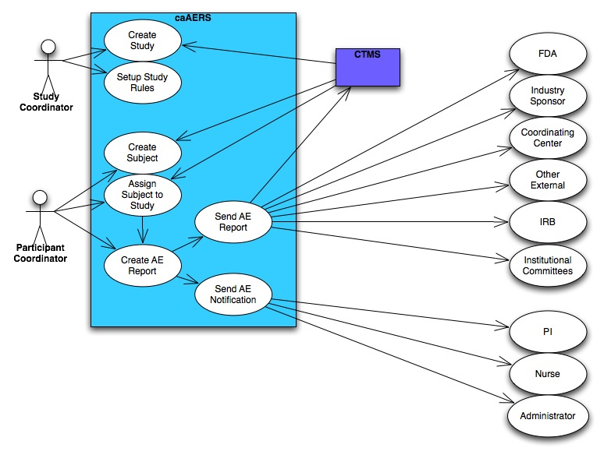

Document Overview
This document presents design-level use cases organized by the four modules currently under development. This document defines a use case as a sequence of actions that an actor (usually a person, but perhaps an external entity, such as another system) performs within a system to achieve a particular goal.

Related Documents
Document Name | Version | Location
caAERS Vision and Scope | V 1.0 | https://gforge.nci.nih.gov/plugins/scmsvn/viewcvs.php/docs/Management/caAERS%20Vision%20and%20Scope.doc?root=caaersappdev&view=log
caAERS System Requirements Specifications Doc | V 1.0 | https://gforge.nci.nih.gov/plugins/scmsvn/viewcvs.php/deliverables/Construction/Iteration%207/caAERS_draft_SRS.doc?root=caaersappdev&view=log

Actors and Goals
These Roles reflect how the functionality of the caAERS application will be partitioned.

Roles
System Administrator  (SysAd) | - Creates new user accounts  - Manages user access to the application  - Approves and manages user registration process  - Grants users to a role within the application  - Generates new passwords when passwords are lost
Study Coordinator (SC) | - Enters Study Protocol abstraction data  - Creates triggers for determining SAEs and reporting requirements  - Configures notification and reporting recipients
Participant Coordinator  (PC) | - Enters Participant data  - Creates AE Reports
Site Principal Investigator | - Is ultimately responsible for the data being generated by a Study at a Site.  - Signs off on AE Reports or designates another user to do so.

Use Cases

Module 1: AE Data Capture

The following Use Cases address the Adverse Event Data Capture Tool, a web-based user interface for manual entry of data surrounding an Adverse Event. Based on information entered through a web interface, the system captures the severity of the adverse event and provides some workflow for identifying and capturing decisions necessary for further reporting.

Create Study for AE Data Entry

Brief Description
Before AE data can be captured for a given Subject and Study, the Study must exist within the caAERS system. In this Use Case, a Study Coordinator (SC) creates an entry in the caAERS system for an existing Study in order to capture AE data. (Note: Module 2 Use Case 2.1 represents the caAERS function for abstracting Study AE data from an existing CTMS system.)

Primary Actor
Study Coordinator (SC)

Preconditions
1. The Study does not already exist in the system.

Basic Flow of Events

- The SC has logged into the system and indicates he/she wants to create a new Study.
- The system displays a page that allows the SC to create a Study.
- The SC enters and saves the data (see Data Item below).
- The system checks for duplicate Study (e.g., match on Site PI, Sponsor name and Sponsor Study ID).
  - If duplicate is found:
    - Alert SC of a possible duplicate study and display details of the duplicate.
    - SC views a page with the possible duplicate study information.
    - SC may choose the following actions:
      - Change study data to modify entered data and continue. (Note: Site PI, Sponsor Name or Sponsor Study ID must be changed or a duplicate warning with occur again)
      - Cancel to the main menu page without creating the new study.
  - If no duplicate is found, continue.
- The system assigns a unique identifier to the Study, not visible to the user.
- The system displays a confirmation to the SC upon successful Study creation.

Postconditions

- Study information is stored in the system and is editable.
- Unique system Study ID assigned.
- Confirmation of Study creation is displayed.

Special Requirements

Data Item:
Data Item | Notes/Validation Rule
Site Principal Investigator | Coded element. Required
Long study title | Required
Short study title | Optional
Primary sponsor name | From LOV Required
Primary sponsor study version date | mm/dd/yyyy- forced format upon typing or calendar
Agents and Devices | Not Required capture any number of these as well as IND or IDE #.and holder of this number
Study IDs | User must enter one, but may enter any number of Study IDs as well as the institution that assigned the ID.
Study Diseases | Not required, capture any number of these.
Phase of Study | Required Added to facilitate triggers, Coded, Required
Sites | In multi-site trials, this describes which sites are involved in performing the trial.

Notes
- The actor is able to exit the function at any time.
- The system will store the following information for audit purposes:
  - User information related to the registered study.
  - The caAERS institution that registered the study.
  - Date and time of activity.
- The combination of data items that trigger a duplicate warning are:
  - Site Principal Investigator name
  - Primary sponsor name
  - Primary sponsor Study ID number

Create Subject

Brief Description
Before AE data can be captured for a given Subject and Study, the Subject must exist within the caAERS system. In this Use Case, a Participant Coordinator (PC) creates an entry in the caAERS system for an existing subject in order to enable AE data capture.

Primary Actor
Participant Coordinator (PC)

Preconditions

- The Subject is qualified and enrolled in the study. (caAERS does not manage eligibility or enrollment workflow.)
- The Subject does not already exist in the system.

Basic Flow of Events

- The PC selects Create Subject.
- The PC enters data about the Subject and submits it (see Data table below).
- The system checks for duplicate Subject using Subject Identifiers, First and Last Name, DOB, and Gender.
  - If duplicate is found:
    - System displays duplicate data
    - PC decides to:
      - Modify data
      - Cancel Subject creation
  - If no duplicate is found, continue.
- The system displays a confirmation to the PC of successfully creating a Subject.

Postconditions
- Subject data is stored in the system.
- The PC is presented with a confirmation of Subject creation.
- The PC must now assign the Subject to a study (see Use Case 1.3).

Special Requirements

Data
Data Item | Notes/Validation Rule
Subject Identifier | At least one is required. The system will allow for any number of these to be specified and will capture the type of the identifier, the issuer of the identifier, and its value. This ID is unique to the Subject independent of the Subject’s participation in a clinical trial.
First Name/Initial | Required
Middle Initial | Not Required
Last Name/Initial | Required
Date of Birth | Mm/dd/yyyy, forced format or calendar, Required
Gender | Coded, Required
Race | Coded, Required (Valid values include “unknown” and “unreported”)
Ethnicity | Coded, Required

Assign Subject to a Study

Brief Description
Subjects must be assigned to a Study before AE data can be abstracted. In this Use Case, the Participant Coordinator (PC) assigns a Subject to a Study. Unless the Subject has already been created and assigned to another Study, this action will immediately follow Subject creation within the UI.

Primary Actor
Participant Coordinator (PC)

Preconditions

- Subject must exist in caAERS system.
- Study must exist in caAERS system.

Basic Flow of Events

Option 1:
1. PC creates a Subject or selects an existing Subject.
2. PC selects a Study and Site.
3. PC saves the assignment of the Subject to the Study.

Option 2:
1. PC selects a Study and Site.
2. PC selects an existing Subject.
3. PC enters StudySubject ID and submits the assignment of the Subject to the Study.

- The System will generate an alert if a duplicate assignment is found.
  - PC will be able to:
    - Cancel assignment
    - Select a different Study
    - Select a different Subject

Postconditions
1. Subject assignment to a study is recorded in the caAERS system.

Special Requirements
Data
Data Element | Notes/Validation
StudySubjectID | Should support multiple institutional and sponsor-assigned identifiers

Study Abstraction – Sponsors, Committees and Organizations

Brief Description
This use case links sponsors, committees and organizations (entered as “Organizations” into caAERS) that are important to the management of the Study as they relate to the recording and reporting of AEs. The Study Coordinator will be able to enter/update information about these entities. The basic course of action is to link an Organization to the protocol by adding the Organization to a collection associated with the protocol. The SC will then decide whether the organization is concerned with all AE Reports entered into the system or only for those Reports which involve a particular Agent or Device.

Primary Actor
Study Coordinator (SC)

Preconditions
- The Study exists in the system.
- SC has entered all appropriate institutional values for the coded elements: Sponsor, Committees and Organizations into the system.
- SC has found the desired Study.

Basic Flow of Events

- The SC navigates to the Study abstraction screen – Sponsors, Committees, and Organizations.
- The SC searches for the desired protocol (Use Case 1.13).
- The SC selects a Sponsor, Committee, or Organization and associates it with the Study.
- The SC enters the appropriate data regarding this association. (See Data table)
- The system stores the information.

Postconditions
- Sponsors, committees and/or organizations have been associated with the Study.

Special Requirements
Data Items
Data Item | caAERS Class (Types)
Entity | Sponsor, Committee, Funding Agency, External Regulatory Agency, Multi-Center Consortium
Entity Name
EntityID (e.g. sponsor ID)

NOTES:
Detailed information about the Sponsor, Committee, or Organization will be entered and edited through an administrative interface. To facilitate study-specific changes in this information, the Study Coordinator may need to have access to this interface, but it will not be reentered here. The Actions taken with respect to these entities will be described by the Rulesets.

Create Expedited AE Report

Brief Description
The Participant Coordinator (PC) creates a new Expedited AE Report for a given Subject assigned to a Study. This report is manually entered into caAERS so that the system can verify that the report should be treated as expedited and determine which entities should receive copies of the report. If caAERS determines that the report does not require expedited reporting, the PC will decide to either submit it as expedited anyway or move to the Routine Report.
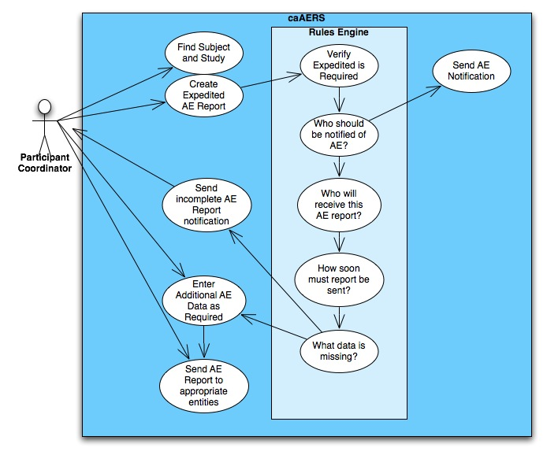

Primary Actor
Participant Coordinator (PC)

Preconditions

1. The Study has been created.
2. The Subject has been created and assigned to the Study.

Basic Flow of Events

- The PC searches for and selects a Subject on which to begin an Expedited AE Report. If the Subject is linked to multiple Studies, the applicable Study must also be selected.
- The PC selects option to create a new Expedited AE Report.
- The initial data screen is presented with Study and Subject identified.
- PC prompted to input the required data to create an Expedited AE Report.
  - If Report is a duplicate (based upon AE terms and Report Date as well as Study and Subject IDs):
    - PC may continue to submit duplicate report.
    - PC may change values and submit again.
    - PC may cancel report.
  - If Report is not a duplicate, data is submitted to system.
- caAERS determines if the AEs entered actually require Expedited Reporting.
  - If yes, move to Step 6.
  - If no, PC may either submit an Expedited report anyway as per Step 6, or may move to the Routine AE workflow (Use Case 1.6) to enter additional Routine AEs. The data that has already been entered will appear in the Routine flow.
- PC receives a confirmation screen and may now continue AE data collection (see Use Case 1.7) or can navigate away from this screen and return later to enter the additional data.

Postconditions
- PC will have created an Expedited AE Report for a Subject assigned to a Study.
- Rulesets for determining which reports should be sent and which fields are required are invoked.
- System prepared for subsequent AE data collection.
- The AE Report is in state “pending.”

Special Requirements

Data Item
Data Item | Type | Notes/Validation Rules
Start Date of Primary AE | Required
End Date | Not required, only entered if applicable
MedDRA Code | Required if AE category and term not provided.
Category | Required for CTEP studies and if MedDRA Code not provided. | CTCAE
MedDRA Version | Required if MedDRA codes are used. | caAERS will use the whole-number, annual releases of MedDRA.
CTC Version | Required for CTEP studies and if MedDRA Code not provided. | CTCAE v2.0/3.0 Should be collected during study abstraction.
Term | Required for CTEP studies and if MedDRA Code not provided. | Also provide an “Other, Specify ____” text box
Grade | Required | If CTC is used, only appropriate grades for each term should be available for selection.
Expectedness | “Requiredness” dictated by configured institution, sponsor and study triggers | Timing of reporting dictated by configured institution, sponsor and study triggers
Attribution | “Requiredness” dictated by configured institution, sponsor and study triggers | Timing of reporting dictated by configured institution, sponsor and study triggers
Hospitalization | “Requiredness” dictated by configured institution, sponsor and study triggers | DCP or CTEP definitions may be utilized
Treating Physician | Required | Coded using CTEP identifiers when possible

Enter Routine AEs
Brief Description
The Participant Coordinator enters routine AEs for a given Subject over a certain time period and for a certain Study. The data is manually entered into caAERS so that the system can verify that an expedited report is not required. If an AE qualifies as expedited, the system will begin an expedited report and give the PC the option to move to the Expedited AE Report workflow.
Primary Actor
Participant Coordinator (PC)
Preconditions
1. The Study has been created.
2. The Subject has been created and assigned to the Study.
Basic Flow of Events
1. PC chooses to enter routine AEs.
2. PC selects Subject and Study.
3. PC chooses start and end dates for the time period being covered by this collection.
4. PC chooses the appropriate AE Categories and Terms.
5. PC fills in the Grade, Attribution, Expectedness, and Hospitalization for each term.
6. Upon saving, caAERS determines if an expedited report is required for any of the AEs.
a. If not required, the AEs are simply saved to the database and the flow ends.
b. If Expedited is required, PC will be given the option to move to the Expedited workflow (Use Case 1.5).
Postconditions
Routine AEs exist in the database.
Special Requirements

AE Data Collection

Brief Description
A Participant Coordinator (PC) enters additional data about an AE which already exists in the system. The “requiredness” of data elements is dynamically determined based upon configured triggers and reporting needs.
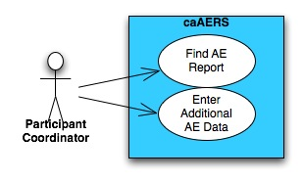

Primary Actor
Participant Coordinator (PC)

Preconditions
1. The AE Report already exists in the system.
2. Notification triggers have been setup.

Basic Flow of Events

- The PC selects option to search for AE Report entries by Study Participant and Protocol. (Use Case 1.7). Protocol-specific codes should show up first.
- The PC selects the desired AE Report.
- caAERS displays the AE Report data entry screen with current data.
- The PC completes dynamically generated data collection (Use Case 4.2) form which comprises the core data elements required for the indicated reporting agencies as determined by the triggers. PLEASE SEE SAE Form Elements spreadsheet for the identification of elements comprising the core data set as determined by requirements from all external reporting agencies
- The PC submits data.

Postconditions
- After successful completion of this use case, the SC will have saved edits to an existing AE for a Study Participant linked to an existing protocol.
- Time stamp of last saved edits with User ID are readily viewable. An audit log of updates is available.
- Reporting triggers and notifications are invoked and updated as data collection occurs.
- The report can be saved and edited any number of times. Once all of the required fields have been completed, the AE report is considered to be complete.

Special Requirements
See Data form

Search AE Entry

Brief Description
Participant Coordinator searches through existing AE Reports to find one of interest.

Primary Actor
Participant Coordinator (PC)
Preconditions
The AE Report must already exist. The PC should know the Study and Participant for whom he or she is seeking the AE Report.
Basic Flow of Events
  - PC selects the Study and Participant for whom he or she is seeking the AE Report.
  - caAERS presents the PC with a chronological list of AE Reports for the Participant on the Study.
  - PC selects a report and views the data.

Postconditions
AE Report is displayed

Module 2: Interface to Local Clinical Trial Databases

This component will provide a standards-based API for integrating the Adverse Event Data Capture tool with an adopting institution’s clinical trials management database. This may include a webservices or caGrid interface, depending on the touch points required.

Import Study Data

Brief Description
Study Coordinator imports XML files containing information about Studies. The import process creates the Studies within the caAERS database and makes them available for the association of patients and the creation of protocol-specific rule sets.
Primary Actor
Study Coordinator (SC)
Secondary Actors
A data manager or other IT personnel will first have to create the XML files, most likely from data within the existing CTMS.
Preconditions
Properly formatted XML file exists and is available to the SC.

Basic Flow of Events
    - SC chooses to “Import Studies.”
    - A wizard is launched, prompting SC for the location of the XML file.
    - caAERS verifies that each record in the file is properly formatted and does not already exist in the caAERS database.
    - caAERS records which studies were imported, which were not, and the reason for those that were not. This information is displayed onscreen to the SC.

Postconditions

Study is available in the caAERS database. Rule sets can be associated with the Study and Patients can be assigned to it.

Special Requirements

XML Schema: https://gforge.nci.nih.gov/plugins/scmsvn/viewcvs.php/docs/import/studyXSD.xsd?root=caaersappdev&view=log
XML Example: https://gforge.nci.nih.gov/plugins/scmsvn/viewcvs.php/docs/import/studyX.xml?root=caaersappdev&view=log

Import Patient Data

Brief Description
Study Coordinator imports XML files containing information about Patients, including on which study or studies the patients are enrolled.
Primary Actor
Study Coordinator (SC)
Secondary Actors
A data manager or other IT personnel will first have to create the XML files, most likely from data within the existing CTMS.
Preconditions
1. Properly formatted XML file exists and is available to the SC.
2. The studies on which patients are enrolled must already exist in caAERS.

Basic Flow of Events
- SC chooses to “Import Patient Data.”
- A wizard is launched, prompting SC for the location of the XML file.
- caAERS verifies that the file is formatted properly.
- caAERS verifies that each record in the file does not already exist in the caAERS database.
- SC is presented with a screen that shows which Patients were imported and which were not (due to formatting or duplication errors).

Postconditions

Patient data has been loaded into the caAERS database. AE reports may now be entered for the Patients.

Special Requirements

XML Schema: https://gforge.nci.nih.gov/plugins/scmsvn/viewcvs.php/docs/import/participantXSD.xsd?root=caaersappdev&view=log
XML Example: https://gforge.nci.nih.gov/plugins/scmsvn/viewcvs.php/docs/import/participantX.xml?root=caaersappdev&view=log

Module 3: Mapping to Vocabularies and Coding Systems

The reference architecture and data services will utilize the mappings created in other projects and available through the caDSR to facilitate customized reports and forms based on the user’s vocabulary preferences.

Select Appropriate Vocabulary for Study

Brief Description

During Study Abstraction, the Study Coordinator will be able to select one of three Adverse Event vocabularies to be used for the study: CTC v2, CTCAE v3, and MedDRA v9.

Primary Actor

Study Coordinator (SC)

Preconditions
1. Study information is being abstracted.
2. Adverse event vocabulary is known.
Basic Flow of Events
1. During study abstraction, SC selects dropdown box labeled AE Vocabulary.
2. SC chooses the appropriate vocabulary: CTC v2, CTCAE v3, or MedDRA 9.0.
3. SC saves this abstraction.
Postconditions
The proper vocabulary will be available for routine AE and expedited reporting for this particular study.
Special Requirements
1. In order to support MedDRA licensing requirements, users will have to upload MedDRA into the caAERS database.
2. Only one vocabulary will be used for each study.

Module 4: Report Generation and Submission to External Agencies

caAERS will provide interfaces and methods for the messaging of AEs to systems external to the local adopter. We anticipate that this will include two-way communication of adverse events with cooperative groups, national studies, study sponsors, the NCI and the FDA.
The following diagram shows the use cases of Module 4, which describe the creation of Rulesets, Notifications, and Report definitions.

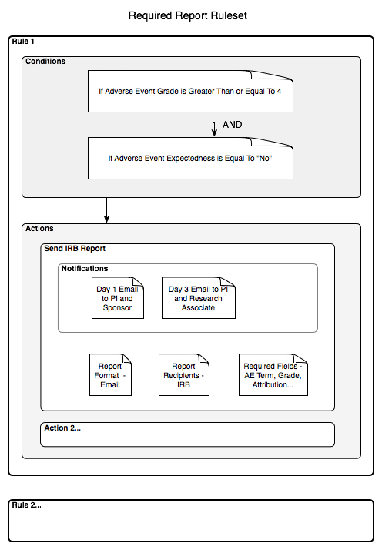

Create Report Definition

Brief Description
Study Coordinator will be able to define a report and determine which fields will be included in it. The sending of this report will then be available as an action to the Rulesets.
Primary Actor
Study Coordinator (SC)
Basic Flow of Events
1. SC selects the “Reports” tab.
2. SC selects “Create Report” option.
3. SC enters a unique name and maximum time from initial creation to submission of report.
4. SC creates as many notifications as needed and enters recipients as either role names or actual email addresses. (See Use Case 4.3 below)
5. SC selects which fields will be mandatory for this report.
6. SC saves the report definition.

Postconditions
1. When creating Rulesets, the Report Definition will be available as a possible action if the conditions of the Rule are met.
2. When a Ruleset fires and determines that the Report is required, mandatory fields will be designated and verified.

Note: For creation of Ruleset, please see Use Case 1.9 above.

Create AE Ruleset

Brief Description
This use case will describe the creation of AE Rulesets. A Study Coordinator (SC) will create a Ruleset in the administrative interface and designate a Ruleset as being a Study, Sponsor, or Site Ruleset. The Rulesets are evaluated when an AE Report is created.

Primary Actor
Study Coordinator (SC)

Preconditions
The appropriate Study, Sponsor, and Site have already been created.

Basic Flow of Events
1. SC selects option to create a new Ruleset.
2. SC chooses a title for the Ruleset.
3. SC chooses from drop-down list whether the Ruleset is a Study, Sponsor, or Site level Ruleset.
4. SC creates a new rule.
5. SC creates a condition consisting of an attribute from an AE Report, an operator, and a value. (See chart below for possible attributes of a condition.)
6. SC repeats step 5 as necessary to complete the rule. Each condition has an AND relationship to the other conditions within the rule. The rules have an OR condition with each other. (See chart below for conditions.)
7. SC selects the agenda that will be executed if the conditions of the rule are satisfied.
8. SC repeats steps 4 thru 7 for each rule in the Ruleset.
9. If Ruleset is a Study-level Ruleset, SC will select the appropriate Study with which to associate the Ruleset.
10. If Ruleset is a Sponsor-level Ruleset, SC will select the appropriate Sponsor with which to associate the Ruleset.
11. If Ruleset is a Site-level Ruleset, SC will select the appropriate Site with which to associate the Ruleset.

Postconditions
1. The SC has created a Ruleset that will be run after initial AE data is entered and saved. .
2. The SC will be able to run a set of test data to verify that the rules function properly.

Special Requirements
Data Item
Data Item | Type
Ruleset Name | Required
Ruleset Type | Required, Study, Organization, or Site
Report Attributes: | One selected for each condition of a rule
Grade | Not Required
Hospitalization | Not Required
Expectedness | Not Required
Phase | Not Required
Attribution | Not Required. Must be selectable in terms of particular agents or devices being used on the trial.
AE Term | Not Required. (CTC or MedDRA)
Operators | Required, =, <, >, <=, >=, <>
Actions | Required. Defined in Administrative Interface

Configure Messages, Timing and Escalation Rules for Notifications

Brief Description
The Study Coordinator configures the notifications that should occur if the conditions of a certain ruleset are met at the time an AE Report is saved. The timing of the notifications relative to the save action will be specified as well as the message format and content.
Primary Actor
Study Coordinator (SC)

Preconditions
None for creation, but notification recipients must be defined and the notifications must be associated with a ruleset before any notifications can actually be sent.

Basic Flow of Events
- SC chooses to “Create Notifications.”
- SC names the particular sequence of notifications that is being created.
- SC selects when the notifications will occur relative to the report save.
- SC selects the format and creates the content of the notifications.
- SC selects the recipients for the notifications. These may be the predefined roles within the caAERS system (see Section 2) or actual contact information.

Postconditions
Notification exists and is ready to be associated with a ruleset.

Special Requirements
Data Item
Data Item | Description
Notification name | Name of this particular series of Notifications
Notification calendar | Collect of timings that tell when notifications should be sent
Notification type | Format of the notification: email, page, SMS, etc…
Notification content | The body (content) of the notification
Notification recipient | Who receives the notification. This could be a variable or a constant.

Import Rulesets

Brief Description
The Study Coordinator imports a Ruleset into caAERS.
Primary Actor
Study Coordinator (SC)

Preconditions
The Sponsor or Organization to which the Ruleset refers must already exist within caAERS.

Basic Flow of Events
- SC obtains a file containing the Ruleset.
- SC chooses to import the Ruleset.
- SC tells caAERS the location of the file to be imported.
- caAERS imports the Ruleset.

Postconditions
Ruleset exists within the system and may be deployed to a Study.

Export Rulesets

Brief Description
The Study Coordinator exports a Ruleset to a file.
Primary Actor
Study Coordinator (SC)

Preconditions
The Ruleset already exists within caAERS.

Basic Flow of Events

- SC chooses to export the Ruleset.
- SC tells caAERS the name of the file and the location to which it should be exported.
- caAERS exports the Ruleset.

Postconditions
A file containing the Ruleset exists which can then be imported into another caAERS instance.

CTMSi Use Cases
caAERS is a part of the CTMS Interoperability project (CTMSi). The following Use Cases describe the ways in which caAERS will interact with the other CTMS modules as part of CCTS 1.0.

  - Push AE notifications to Patient Study Calendar
Brief Description
While viewing an AE Report for a Subject, the Participant Coordinator will be able to click a button to send information about the primary AE in the report to the Patient Study Calendar (PSC). This will alert the next person who views the Subject’s schedule that a SAE has occurred and modifications to the Subject’s treatment may be necessary.
Primary Actor
Participant Coordinators (PC)
Secondary Actors
User of PSC.
Preconditions
1. Subject’s schedule has been generated in PSC.
2. Expedited AE report has been created for the Subject.
Basic Flow of Events

1. PC is viewing an Expedited report for a Subject.
2. PC decides to send an alert to the Subject’s calendar.
3. PC clicks a button to send data about primary AE to PSC.
4. PC receives a confirmation that PSC received the data.

Postconditions

An alert will show in the Subject’s calendar within PSC.

Special Requirements

Both caAERS and PSC must be configured as per CCTS specifications.

Create Expedited Report with Data from CTOM Lab Viewer

Brief Description
While viewing lab results within CTOM Lab Viewer, the user can click a button to send the data from a particular lab to caAERS. When caAERS receives this data, it will create and save an Expedited Report with this lab value as the primary AE. A Participant Coordinator may then use the caAERS interface to enter additional information about the AE or add AEs to the report.

Primary Actor
Lab Viewer User (LVU)

Secondary Actor
Participant Coordinator (PC – caAERS)

Preconditions
1. Subject exists within both Lab Viewer and caAERS.
2. Lab data is available in Lab Viewer.

Basic Flow of Events
1. LVU is viewing lab data in Lab Viewer and notices a value that qualifies as an AE.
2. LVU clicks button to send that data to caAERS.
3. caAERS receives data and creates and saves an Expedited Report.
4. caAERS sends confirmation of report creation back to Lab Viewer.
5. Lab Viewer saves and displays the date that the lab data was reported to caAERS.

Postconditions

1. Expedited Report saved in caAERS.
2. The date that the lab data was sent to caAERS is saved in Lab Viewer.

Special Requirements

Both caAERS and Lab Viewer must be configured as per CCTS specifications.

Receive Patient Registration from C3PR

Brief Description
When a patient is registered to a Study in C3PR, that registration can be sent to caAERS. The Study must already be in the caAERS database, but the patient will be added if he or she does not already exist.

Primary Actor
C3PR (Cancer Center Clinical Participant Registry) User

Secondary Actor
caAERS

Preconditions
The Study must already exist within both caAERS and C3PR.

Basic Flow of Events
1. C3PR User registers a patient to a Study
2. C3PR sends registration message to caAERS
3. If patient already exists in caAERS database:
a. Patient is registered to Study.
4. If patient does not already exist in caAERS database:
a. Patient is added to caAERS database.
b. Patient is registered to Study.

Postconditions
1. Patient is registered to Study in caAERS.
2. AEs may now be entered for the Patient on the Study.

Special Requirements

Both caAERS and C3PR must be configured as per CCTS specifications.

Sign Off

Approval

Workspace General Contractor Rep Print Name Date
Architecture Workspace Rep Print Name Date
VCDE Workspace Rep Print Name Date
Workspace Working Group Rep Print Name Date
NCICB Rep Print Name Date

